Noise-Resilient Lip-to-Speech Recognition for Communication Assistance

Bhaaskar Krishna, Nikhil S Tengli, Harsh Chauhan, G L Meghana, Shreeshail S Y
School of Computing & Information Technology, REVA University, Bangalore, India

Abstract – The science of lip reading is not a recent development. It has been the subject of consistent research and development over the last several years, leading to significant breakthroughs in audio and audio-visual speech recognition. Utilization of lip reading has been extensively implemented across diverse domains, including but not limited to speech recognition, security, and human-computer interaction. Nonetheless, the task of lip-reading presents significant challenges due to a multitude of factors, including the high degree of similarity between lip shapes across different classes, the substantial variability within classes resulting from diverse accents, and the presence of environmental noise. Many contemporary techniques have achieved impressive results by developing intricate neural networks, alongside a few tailored training approaches that were often presented in a concise manner or solely accessible through the source code. It has been observed that the effective implementation of these strategies can lead to significant enhancements without necessitating substantial modifications to the model. Considering the significant impact of these strategies and the current challenges associated with training an efficient model for lip reading, We carried out a thorough quantitative examination and analysis, which exhibited the results related to different types of lip reading methods. Through the implementation of straightforward modifications to the fundamental pipeline, a discernible enhancement in performance is achieved, resulting in a rise from 83.7% to 88.4% and from 38.2% to 55.7% on the two most extensive publicly accessible lip-reading datasets, namely LRW and LRW-1000, correspondingly. The results obtained are comparable to, and in some cases, surpass the existing state-of-the-art results.

Index Terms – lip reading, visual-speech recognition, deep learning, pipeline, region of interest (ROI), Temporal Convolutional Networks (TCN)

INTRODUCTION
Lip reading is a technique employed to identify the spoken language by analyzing the auditory signals of the speaker's mouth movements. For numerous years, it has been researched as a potential substitute or supplementary technique to audio speech recognition. The practice of lip-reading can prove to be especially advantageous in settings with high levels of ambient noise or for those who experience hearing disabilities. The task of lip-reading is known to be arduous owing to the considerable variability in visuals generated by diverse speakers and the absence of distinct correspondences between visual cues and phonemes.
In scenarios where the video is captured in a noisy setting, it is possible to improve the clarity of a speaker's voice by leveraging the observable movements of their mouth, thereby mitigating the impact of ambient noise [1]. Most current techniques rely on audio-only inputs; however, enhanced performance can be achieved through visual speech enhancement, which is founded on an audio-visual neural network [2]. The synergistic attributes provided by the visual data remain impervious to any auditory interference present in the surroundings. This system is impervious to any acoustic noise or disturbances present in a noisy environment. The investigation of visual speech is a captivating topic that has been implemented across various fields, such as enhancing interactions between humans and computers, ensuring security, and advancing digital entertainment [3].
The concept of noise-resilient lip-to-speech recognition pertains to using artificial intelligence (AI) algorithms to convert lip movements into speech, even when high levels of noise characterize the surroundings. The potential of this technology is significant in aiding individuals who experience hearing impairments, as well as those who encounter speech-related challenges such as muteness or speech impediments. Numerous machine lip-reading models have been proposed subsequently; however, they encounter challenges in extracting spatio-temporal features from the video. The initial approaches for automating lip-reading involved conventional learning techniques incorporating manually designed methodologies. Hidden Markov Models (HMMs) are among the techniques that fall under this category [4]. Modern networks are now being used for feature extraction and categorization by a growing number of visual speech recognition systems.
There are two points that make automatic lipreading possible. Firstly, Action recognition, sequential modelling, and other issues that are closely connected to lip reading have all been successfully addressed by the recently established deep learning approaches. Fortunately, there have been promising outcomes in the field of lip reading through the utilization of deep learning techniques that can automatically acquire distinguishing characteristics from unprocessed information. Convolutional Neural Networks (CNNs) are effective in extracting spatial features from images, while Long Short-Term Memory (LSTM) networks are powerful in capturing temporal dependencies in sequential data. Some of the works have even explored combining CNNs and LSTMs for lip reading. However, most existing methods simply concatenate CNN and LSTM outputs without considering the specific characteristics of lip movements, which may not fully exploit the temporal information of lip sequences.
Secondly, a plethora of extensive datasets have emerged recently, with a primary focus on lip-reading. These datasets contain substantial variations and have played a significant role in advancing the field of lip-reading. Typically, contemporary models for lip reading comprise of distinct components, namely the front-end and back-end modules. The analysis of local motion patterns, encompassing both frame level and clip level features, is a common focal point within the front-end module. Conversely, the back-end component assumes the responsibility of detecting patterns at the sequence-level and has typically been developed with the aim of capturing the temporal-dynamics of the sequence. To achieve this, it has been engineered to utilize the output features. generated by the front-end component. Although the structures of many models may be divided into these two parts, the most effective methods, or pipelines for promoting learning in the lip-reading model have not yet been universally agreed upon. Different works often use different strategies to accomplish effective lip-reading.
Here, we provide a 3DCNN + Transformer-based lip-reading method.
A lip-reading system based on 3DCNN+transformer is a type of lip-reading system that uses a combination of 3D convolutional neural networks (CNNs) and transformers to identify and transcribe spoken words from visual input. 3D CNNs are one of the different types of neural network that is well-suited for processing video data. They are able to extract spatial and temporal features from video frames, which can be used to identify the movement of the lips. Transformer is a type of advanced neural network that is well-suited for processing sequence data. The acquisition of long-term dependencies among words can be leveraged to enhance the precision of lip reading.
In detail, the encoder is an essential component in the lip-reading systems, as it is responsible for extracting the features that are necessary for the decoder to identify and transcribe spoken words. The system's encoder may extract characteristics from the video frames' spatial and temporal dimensions, giving the decoder the information required to infer long-distance relationships. Lip reading systems based on 3DCNN+transformer have been shown to be more accurate than traditional lip-reading systems that use only 3D CNNs. This is because transformers can learn long-range dependencies between words, which can help to compensate for the challenges of lip reading, such as occlusion, lighting, and noise.
Here is a more detailed explanation of how a lip-reading system based on 3DCNN+transformer works [5]:
- The encoder receives a sequence of video frames.
- The system's encoder employs a set of 3D convolutional network layers arranged in a stack to extract the spatio-temporal features from the frames of the video.
- The extracted features are then passed to the decoder.
- The decoder then uses the extracted features to identify and transcribe the spoken words.
The encoder of a transformer is a key component of a 3DCNN+transformer-based lip-reading system. The encoder can extract the features that are necessary for the decoder to identify and transcribe spoken words. As technology continues to improve, lip reading systems based on 3DCNN+transformer will become more accurate and reliable, and they will be able to be used in a wider variety of settings.
The objective of our research is to showcase the potential of the proposed model in generating a diverse range of artistic outputs using the LRW and LRW-1000 database. The study's key components are categorized into three primary domains. One potential approach is to incorporate lip alignment as a data augmentation technique during the training preprocessing phase. This would allow for a more targeted emphasis on the nuances of lip movement, which can be considered a form of pose variation. Second, knowledge distillation to attain state-of-the-art performance. In the third or last domain all three lip-alignment, and spatiotemporal attention is narrowed down to deliver a continuous novel result.

The paper has been arranged as follows, Section II contains the related work previously done by the authors in the field of Lips-to-Speech Recognition. Section III consists of the Methodology, and the description of the dataset used, Section IV is about our outcomes and the results obtained by our proposed model followed by conclusion and references done in our paper.

RELATED WORK
The study of lip reading has a lengthy historical background and has garnered growing interest in contemporary times. W.H.Dumby and I.Pollack were the ones who originally proposed it. Although in 1984, a real automatic lip-reading system (Petajan) was established at the University of Illusion. The traditional computer methods were based on different lip-reading approaches. The past studies of this survey in the year 1984 [6] presented the first lip-reading system that was able to recognize solo words. It computes the characteristics of the series of lip images and compares them with the features of all sample images in the index characteristic. The same features are extracted as the new prognosticate results. Two approaches were suggested for extracting lip characteristics. The provisions studies suggested that the two proposed methods were methods based on image change and a technique utilizing the curves of lips. To overcome the difficulty of isolated phase identification, in 2007, a technique utilizing space-time local binary features was introduced. [7], which involved the utilization of SVMs (Support Vector Machines) for the purpose of phrase recognition.
Research on lip reading gives multiple explanations on how the technique selects and tracks visual areas of interest [8].
previous work on the lips reading as well as statical models utilize the visual features extraction in the temporal modeling which was described in the abroad survey conduct conducted under the supervision of different experts as well as presented in different methods.
Handcrafted visual feature extraction has been extensively studied, with numerous methods proposed that rely on visual signal processing algorithms and automatic feature extraction through the utilization of neural networks. Automated lip-reading is a multidimensional field of study [9]. Techniques such as convolutional auto-encoder, long short-term memory, residual networks, and spatial temporal convolutional neural networks have become the most popular techniques. The field of automatic speech recognition (ASR) has made significant progress, introducing advanced models that have demonstrated enhanced performance across various benchmarks. Considerable research has been devoted to the study of lip reading to enhance speech comprehension through visual and auditory information, akin to human bimodal perception [9].
The advancement of lip-reading technology has been facilitated by the advancements in deep neural networks and the availability of extensive databases containing diverse vocabularies. These systems have progressed from identifying individual speech units, such as digits and letters, to deciphering complete sentences. Convolutional Neural Networks (CNNs) are a prevalent type of neural network utilised in the development of lip-reading frontends [4]. CNNs are the predominant neural network frontends due to their superior ability to learn spatio-temporal features and their increased efficacy in extracting pertinent features. The creation of innovative deep learning architectures requires access to substantial annotated training datasets, a resource that remains scarce for numerous languages at present. Currently, datasets for lip reading are not as widespread as for speech recognition [10]. The application of machine learning involves classifying and predicting novel data through identifying patterns within pre-existing data [12]. The categorization of words extracted from a visual data stream is achieved through the utilization of artificial neural networks (ANN) [11]. Recurrent neural networks (RNNs) are a commonly utilized form of ANNs that exhibit broad utility within the field of speech recognition. RNNs possess a distinctive characteristic of retaining information through the utilization of recurrent neural network loops.
In contemporary times, there exists a desire for an automated reading device that is both cost-effective and accurate, while also possessing the quality of portability. Typically, a lip-reading system comprises three distinct modules: visual feature acquisition, temporal modelling, and the generation of speech content in text format [8]. The establishment of an effective lip-reading system poses a significant challenge due to the simultaneous involvement of three areas, specifically, in the fields of computer vision technology, speech recognition, and natural language processing (NLP). This added complexity exacerbates the inherent difficulty of the problem. Python language is utilized to automate the entire process and ensure sequential operation of the system. Python is a high-level programming language that is interpreted and commonly utilized for general-purpose programming [13].
The development of lip-reading technology has resulted in the identification of words and progress towards sentence-level recognition. This has been achieved through the implementation of diverse models, including the LSTM sequence to sequence and CTC approaches, for the purpose of automatic speech recognition (ASR). Researchers are presently investigating the potential benefits of utilizing extensive datasets for training purposes. This can be achieved either by training on private datasets that surpass the size of any publicly available dataset or by condensing Automatic Speech Recognition (ASR) models into lip-reading models.

METHODOLOGY
This project's objective is to develop a lip-reading AI capable of producing words or sentences from a mute video input.
There are various approaches to resolving this issue (listed from lowest to greatest level of abstraction):
- Lip-reading on the phonemes level: For each input frame, prognosticate the corresponding phoneme. While the classification conundrum is relatively uncomplicated (due to a limited set of 44 distinct phonemes in English), the process of ascending to a superior level to compose words or sentences can be demanding. This can be attributed to two factors: (1) a phoneme may be disseminated across several frames, and (2) certain phonemes are indistinguishable (as far as lip movements are concerned, such as distinguishing between a "p" and a "b").
- Lip-reading on the words level: Divide the video sequence into several subsequences, each of which should only include a single word. Then, using a predetermined vocabulary, categories those sequences. Given that the dictionary should include many terms (more than 100), this categorization challenge is more challenging. Additionally, since we must first divide the input into distinct subsequences.
- Lip-reading on the sentences level: Anticipate the words in a sentence by utilizing predetermined linguistic patterns.
Here we chose to work on the word level because even if a high accuracy is not achieved, the output can still be used to enhance speech recognition models.
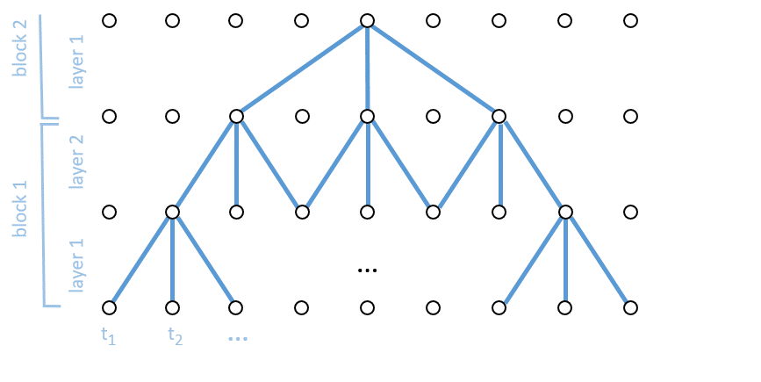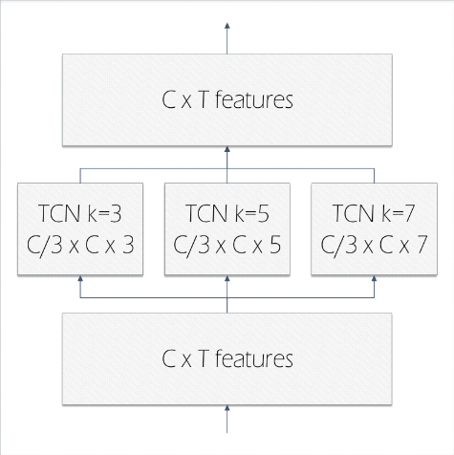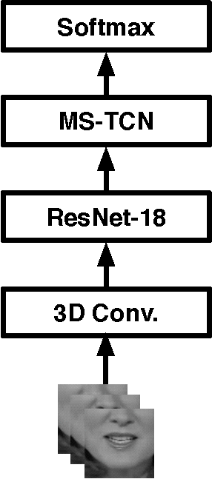
TCN multi-scale TCN lip-reading model

Temporal-Convolutional-Networks (TCNs):

With its temporality and broad receptive fields, Temporal Convolutional Networks (TCN) is a framework that uses casual convolutions and dilations to make it adaptable for sequential inputs.
The work here discusses the possibility of training lipreading from scratch using a convolutional architecture and a state-of-the-art performance is achievable using a cosine scheduler. Within a week of such training, one's GPU may perform at a competitive level. It is also observed that pre-training on a small part of the hardest words, specifically 10% of them, would lead to 50 classes for LRW. This pre-training strategy can result in faster training and a minor improvement in performance.

The concept of augmenting variable length data.

It has been noted that models that are trained on LRW have a propensity to overfit to the situation of the dataset. The target word is always positioned in the center of the 29-frame input sequences used in this case. When trained in a biased environment, a model is more likely to internalize biases and show increased sensitivity to even small changes in the input. As an illustration, the removal of a single frame at random from an input sequence results into a notable decrease in performance. We mitigate the issue of dataset bias through the implementation of variable length augmentation. Each input training sequence will be temporally cropped at a random point before and after the target word boundaries. We assert that this adjustment produces models with improved resilience even if it may not immediately improve the benchmark under discussion.

Pre-processing:
- The LRW dataset undergoes a series of processing steps, including face detection and alignment, as well as frame alignment to the reference shape of the face.
- A region of interest (ROI) is extracted from an aligned face image with a fixed width of 96 × 96 pixels. The ROI is selected in such a way that the mouth region is approximately positioned at the center of the image crop.
- The image should be converted to grayscale as there appears to be no discernible variance in performance when compared to utilizing RGB.
- The oral region of interests (ROIs) has been pre-cropped in the LRW1000 dataset, thus obviating the necessity for any pre-processing.

Deep Lip-Reading
The investigation of lip-reading has a lengthy academic background. Discrete Cosine Transform (DCT), Hidden Markov Models (HMM) and Active Appearance Model (AAM) are only a few examples of the many earlier methods that depend on hand-drawn features and basic models. In recent years, scholars in the field have started to incorporate deep neural networks due to the swift advancements in deep learning methodologies. Chung introduced a novel multi-tower convolutional neural network (CNN) structure that builds upon the VGG-M architecture. For the first time, the results of applying deep learning algorithms to large datasets of lipreading were revealed. The implementation of temporal convolutional network was proposed as a solution to the lip-reading problem. By utilizing these notable techniques, the cutting-edge efficiency was elevated up to 87.3% on the most extensive word-level lipreading dataset LRW with English as the language, within a mere four-year span [8]. Nevertheless, most of these techniques possess their own tailored configuration in either the training methodology or data manipulation. Currently, there is a need for a thorough investigation and comparative evaluation of the factors that have the potential to enhance the efficacy of lip reading.
Bag of Deep Learning Tricks

It has been shown that a variety of training algorithms and architectural improvements may enhance a wide range of computer vision tasks. This collection of training techniques has improved the precision of ImageNet's picture categorization [8]. Considerable efforts are currently being directed towards the domain of object detection, with a specific emphasis on the optimization of training pipelines and architectures. These works offer a standardized and streamlined approach to completing the given task, thereby promoting additional investigation and enhancement of the intended topic.

THE BASIC STRUCTURE OF PIPELINE
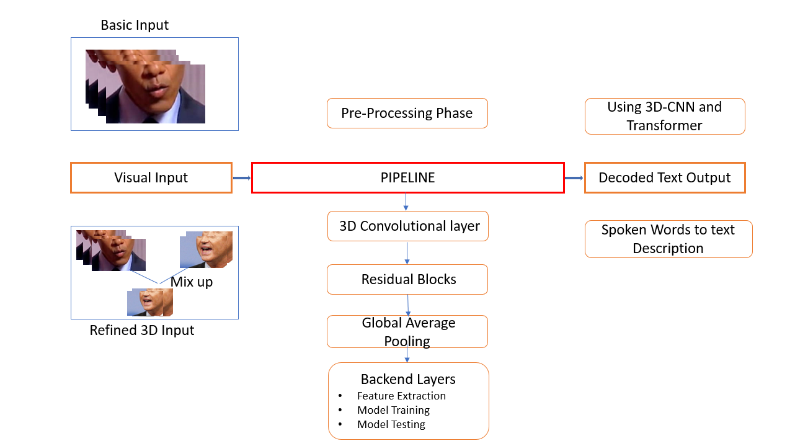
Figure 1
Our baseline approach in the field of lip-reading involves the implementation of a widely used pipeline, as depicted in Figure 1. As the front-end module, ResNet-18 architecture is used. With a kernel size of 577, the original 2D convolutional layer has been changed to a 3D convolutional layer. The resultant output of the resultant blocks is then subjected to a global average pooling procedure, and the resulting features are then sent to the backend network. The total number of word classes is equal to the output dimension of the final fully linked layer. The training environment that we use by default is as follows:

Initialization Process: Using a random initialization method, the parameters of the convolutional and recurrent modules are initialized similarly. [8]. The subject matter can be classified into three discrete categories. The convolutional layer parameters are initialized through a process of randomization, whereby values are uniformly drawn from the interval [-a; a]. The variable p2 is defined as the sum of din and dout, where dout and din correspond to the input and output size, respectively. The affinition function in batch normalization layers involves the computation of y = γx + β. Here, x depicts the normalized form in BN and y denotes the output present in the BN layer. During this process, it is a convention to assign a value of 1 to all γ vectors and a value of 0 to all β vectors.
The Gated Recurrent Unit (GRU) utilizes parameters that are uniformly selected from the interval of (-1, 1), whereas the final fully linked layer's parameters are taken from a uniform distribution with values between -1 and 1.

Data Processing: Setting up an effective data pipeline was one of the project's most crucial yet time-consuming tasks. The dataset couldn't fit in memory; thus, the pipeline's efficiency was crucial. For each iteration, a batch of training samples had to be retrieved from the disc, prepped, and then fed to the neural network after undergoing data augmentation. We decided to take advantage of TensorFlow's data input pipeline to do that. In addition to allowing us to execute all the tasks, it also enables simultaneous use of the CPU and GPU for maximum speed. Therefore, the data for the next phase is prepared before the previous one is complete.

Pipelining refers to the concurrent execution of model training preparation and execution stages. During the training process, as the accelerator finishes executing step N, the central processing unit (CPU) concurrently prepares the data for the subsequent training step, N+1. The approach minimizes the step time to the highest value between the training time and the time required for data extraction/transformation, rather than the overall time.

The present study employs the LRW and LRW-1000 datasets, which represent the largest publicly accessible word-level lip reading datasets, as the exclusive sources of data for all experimental evaluations. The LRW dataset comprises samples of English lip-reading extracted from 500-word classes featured in BBC programs. The LRW-1000 dataset is a collection of Mandarin language lipreading data comprising 1000 distinct word and phrase categories. The dataset features recordings from over 2000 individuals. The term is situated at the focal point of every individual video, comprising a cumulative total of 29 frames. The dimensions of the frames were decreased to 64x64 and subsequently trimmed to encompass solely the speaker's lips.

Every epoch, the input films are mixed, scaled to 96×96, then randomly cropped to 88×88 before being fed into the model. A batch of videos is chosen during each training iteration. The videos undergo a horizontal flip operation with a probability of 0.5, followed by a conversion to grayscale and normalization to a range of values between 0 and 1. The LRW-1000 has a unique set up where each word is split up into 40 frames, with the target word placed in the middle to closely mirror the data in LRW. According to our research, including more contextual information may improve the accuracy of lip reading. The default setting has been implemented in our LRW-1000 experiments.
The preprocessing requisite to convert the input into a 64x64x29 matrix engenders a dual predicament: (1) the conundrum of diminishing the video's spatial dimension by cropping it to encompass the mouth of the speaker, and (2) the enigma of decreasing the temporal dimension from x frames to 29. The former dilemma is resolved by leveraging Adam Geitgey's Python API for facial recognition. The latter predicament, however, is relatively simple to surmount we merely elect 29 equidistant frames from the input video.

In contemporary methodologies, the lip region is commonly circumscribed by a pre-established rectangular shape, with significant information pertaining to word delimitation often overlooked. The present investigation aimed to scrutinize the impact of two variables, as presented in Table 1. [8]

Facial positioning is a beneficial process for the purpose of facial recognition. In a recent study conducted by [7], it was discovered that the precision of visual speech recognition can be enhanced through the implementation of face alignment techniques. Prior to extracting the lip region, we perform facial alignment because of the inspiration drawn from their work.
Using the dlib toolbox and Procrustes analysis, face landmarks are obtained. After a similarity transformation, each picture is center cropped using a set square size to extract the lip area. Through the implementation of these procedures on LRW, it has been determined that facial alignment can be advantageous in the context of lip reading, as evidenced by the results presented in Table 1. The video of the face that has been aligned preserves the yaw and pitch orientations, while eliminating any roll rotation. The present study involves the implementation of a technique aimed at minimizing temporal jittering in facial video data. Additionally, the proposed approach seeks to prioritize the analysis of lip movement over pose variations within the deep learning model.

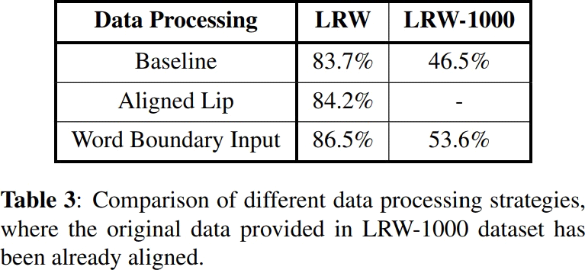
Table 1: This study compares data processing methods assuming the dataset has been aligned.

Loss: Before transferring the outputs to the final fully connected layer for prediction, the backend averages the outputs' temporal dimension. The whole optimization procedure takes advantage of the cross-entropy loss.

Optimizer: The default choice makes use of the Adam Optimizer. The weight decay is 1 times 10 to the power of negative 4, whereas the learning rate is 3 times 10 to the power of negative 4 at the beginning of training. When training the model on a single GPU, the batch size is set to 32. During training on different devices, the learning rate is linearly modified depending on the batch size. At the end of each epoch, the model is validated, and if the validation error stays constant for three successive epochs, the learning rate is reduced by a factor of two. The defined minimum learning rate is 1e-6.

Boundary for the Words: In 2018, Stafylakis proposed a method for incorporating the concept of word boundary into a front-end network by representation of a binary indicator at every time step, which is then combined with the initial features through concatenation. The baseline model for lip reading is utilized to assess this approach. Tabulation 1 demonstrates a noteworthy enhancement upon the introduction of the data. As previously stated, Recurrent Neural Networks (RNNs) possess a robust gating mechanism that, when coupled with the inclusion of word boundaries as a variable, enables the RNN to effectively leverage them. Frames that fall outside of established boundaries have the potential to offer contextual and environmental cues, such as that speaker's identity, lighting conditions, different postures, and some of the other relevant factors, that may prove beneficial in the classification of the intended word.

Learning-Rate Scheduling: The learning rate has a consistent impact on the effectiveness of our lip-reading model. Within the context of the pipeline utilized, the learning rate experiences a decrease of 50% after the validation error achieving a plateau for a period of 3 consecutive epochs. This configuration has the potential to result in a sudden decrease in the rate of learning. Furthermore, a comparative analysis is conducted between cosine-based learning rate scheduling and exponential-based learning rate scheduling. According to an exponential scheduling system, the learning rate is subject to multiplication by 0.95 at the end of every epoch.

Within the context of cosine, the calculation of the learning rate ηt at epoch t is as follows [8]: 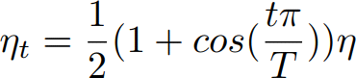

The symbol η denotes the learning rate in the initial phase. In our experiments, the variable T represents numerical value of epochs during the process, and its value is 80. The cosine learning rate schedule is characterized by a gradual reduction in the learning rate during the initial phase, a nearly linear decrease in the middle phase, and a subsequent deceleration in the final phase. In contrast to alternative scheduling methods, the cosine learning rate schedule initiates a gradual decrease in the learning rate from the outset of training, while maintaining a comparatively elevated value. This approach has the potential to enhance the efficacy of the training process.

- RESULTS

With the accuracy rate of 62.1%, the model recognized almost all the phonemes in each instance. Although it gave approximately equal probabilities to words that include each of those phonemes, it struggled with the temporal element. Despite these limitations, lip reading systems can be a valuable tool for people with hearing loss. They can help people to communicate more effectively in a variety of settings.

The following graph summarizes the accuracy and loss statistics of the model.
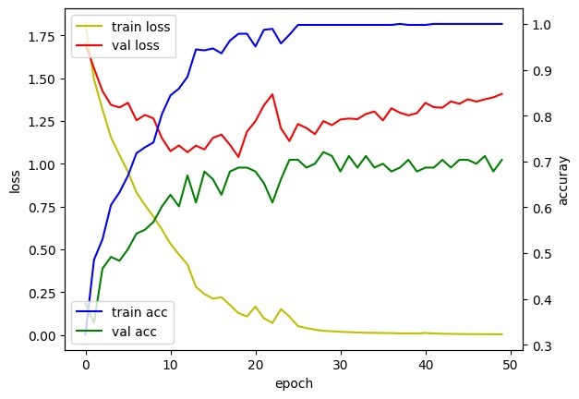

A bar chart showing the model's results in summary form. For the word “hello” the following graphs can be derived:
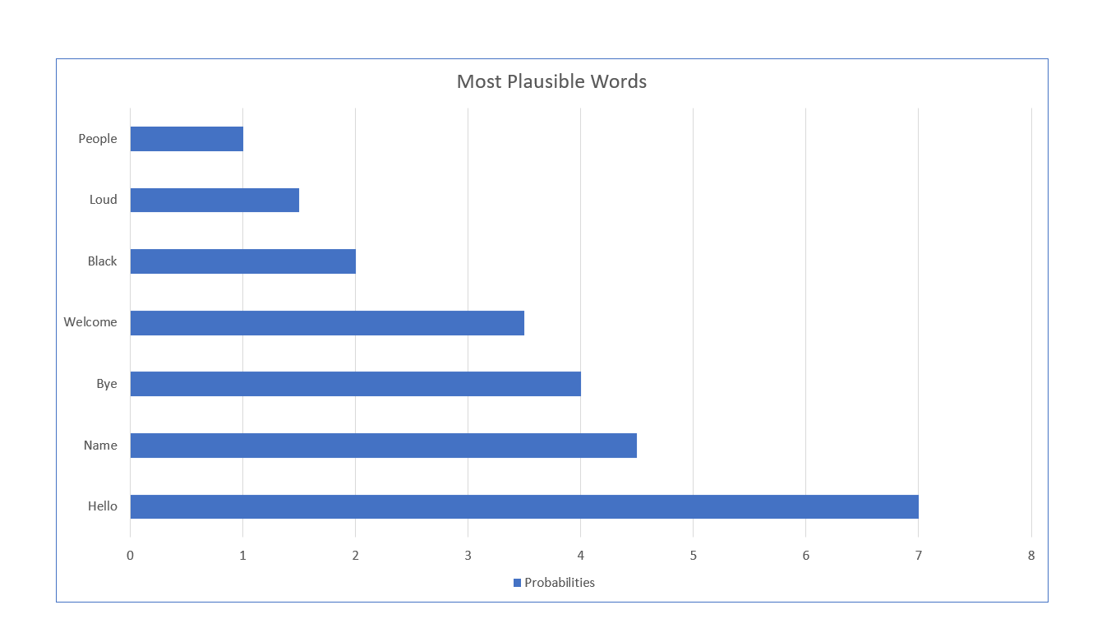

The outcomes were quite encouraging. When applied to videos with poor framing or high brightness and low contrast, the model might be challenging.

- Limitations
- The intra-class variability caused by different accents and speaking styles remains a challenge for lip reading.
- Lip reading systems are not always accurate, and they can often misunderstand what is being said. This is especially true in noisy environments or when the speaker is not facing the listener directly.
- The utilization of lip-reading systems may pose challenges in scenarios where the speaker's lips are concealed, for instance, when they are wearing a mask or positioned with their back facing the listener.
- Lip reading systems can be expensive, and they may not be affordable for everyone who needs them.
- Unable to distinguish single from plural.

CONCLUSION

In this study, we present a cutting-edge lip-reading system. The main aim of this project was to develop an extensive lip-reading system that possesses the flexibility to be utilized in any video. The system comprised a frontend and backend incorporating a 3D-CNN and a Decoder Transformer, achieving a word accuracy rate of 62.1%.
The progression of visual speech recognition systems has transitioned from the utilization of traditional algorithms for the classification of letters and digits to the utilization of deep neural networks for the anticipation of words and sentences. The advancement in this field can be credited to the development of more sophisticated corpora, including but not limited to BBC-LRS2, LRS3-TED, LSVSR, and LRW-1000.

REFERENCES

- Martinez, B., Ma, P., Petridis, S., & Pantic, M. (2020). Lipreading using Temporal Convolutional Networks (arXiv:2001.08702). arXiv. http://arxiv.org/abs/2001.08702
- Gabbay, A., Shamir, A., & Peleg, S. (2018). Visual Speech Enhancement. Interspeech 2018, 1170–1174. https://doi.org/10.21437/Interspeech.2018-1955
- Supriya Patil, Vaibhav Dhoble, Saatvik Gawade, Pratiksha Jagdale, & Rohan Jinde. (2022). Visual Speech Recognition. International Journal of Advanced Research in Science, Communication and Technology, 355–358. https://doi.org/10.48175/IJARSCT-2874
- Fenghour, S., Chen, D., Guo, K., Li, B., & Xiao, P. (2021). Deep Learning-Based Automated Lip-Reading: A Survey. IEEE Access, 9, 121184–121205. https://doi.org/10.1109/ACCESS.2021.3107946
- Brais Martinez, Pingchuan Ma, Stavros Petridis, Maja Pantic (2020). Lipreading using Temporal Convolutional Networks. https://doi.org/10.48550/arXiv.2001.08702
- Petajan E D. Automatic Lipreading to Enhance Speech Recognition (Speech Reading)[J]. 1985.
- Tu, Z., Li, H., Zhang, D., Dauwels, J., Li, B., & Yuan, J. (2019). Action-stage emphasized spatiotemporal VLAD for video action recognition. IEEE Transactions on Image Processing, 28(6), 2799-2812.
- Feng, D., Yang, S., & Shan, S. (2021). An Efficient Software for Building LIP Reading Models Without Pains. 2021 IEEE International Conference on Multimedia & Expo Workshops (ICMEW), 1–2. https://doi.org/10.1109/ICMEW53276.2021.9456014
- Qu, L., Weber, C., & Wermter, S. (2019). LipSound: Neural Mel-Spectrogram Reconstruction for Lip Reading. Interspeech 2019, 2768–2772. https://doi.org/10.21437/Interspeech.2019-1393
- Schwiebert, G., Weber, C., Qu, L., Siqueira, H., & Wermter, S. (2022). A Multimodal German Dataset for Automatic Lip Reading Systems and Transfer Learning. https://doi.org/10.25592/uhhfdm.10047
- Hassanien, A. E., Bhatnagar, R., & Darwish, A. (Eds.). (2021). Advanced Machine Learning Technologies and Applications: Proceedings of AMLTA 2020 (Vol. 1141). Springer Singapore. https://doi.org/10.1007/978-981-15-3383-9
- Munther, D., & Puustinen, D. (2022). A Study of Accumulation Times in Translation from Event Streams to Video for the Purpose of Lip Reading.
- Ting, J., Song, C., Huang, H., & Tian, T. (2022). A Comprehensive Dataset for Machine-Learning-based Lip-Reading Algorithm. Procedia Computer Science, 199, 1444–1449. https://doi.org/10.1016/j.procs.2022.01.183
- Jadoul, Y., Thompson, B., & de Boer, B. (2018). Introducing Parselmouth: A Python interface to Praat. Journal of Phonetics, 71, 1–15. https://doi.org/10.1016/j.wocn.2018.07.001
- Qu, L., Weber, C., & Wermter, S. (2019). LipSound: Neural Mel-Spectrogram Reconstruction for Lip Reading. Interspeech 2019, 2768–2772. https://doi.org/10.21437/Interspeech.2019-1393
- Soundarya, B., Krishnaraj, R., & Mythili, S. (2021). Visual Speech Recognition using Convolutional Neural Network. IOP Conference Series: Materials Science and Engineering, 1084(1), 012020. https://doi.org/10.1088/1757-899X/1084/1/012020
- Xu, B., Wang, J., Lu, C., & Guo, Y. (2020). Watch to Listen Clearly: Visual Speech Enhancement Driven Multi-modality Speech Recognition. 2020 IEEE Winter Conference on Applications of Computer Vision (WACV), 1626–1635. https://doi.org/10.1109/WACV45572.2020.9093314
- Zaman, H. U., Mahmood, S., Hossain, S., & Shovon, I. I. (2018). Python Based Portable Virtual Text Reader. 2018 Fourth International Conference on Advances in Computing, Communication & Automation (ICACCA), 1–6. https://doi.org/10.1109/ICACCAF.2018.8776778
- Abhishek Jha, Vinay Namboodiri, and C. Jawahar. Spotting words in silent speech videos: a retrieval-based approach. Machine Vision and Applications, 30, 03 2019.
- Brendan Shillingford, Yannis Assael, Matthew W. Hoffman, Thomas Paine, C´ıan Hughes, Utsav Prabhu, Hank Liao, Hasim Sak, Kanishka Rao, Lorrayne Bennett, Marie Mulville, Ben Coppin, Ben Laurie, Andrew Senior, and Nando de Freitas. Large-Scale Visual Speech Recognition. In INTERSPEECH, 2019.
- Easton R D, Basala M. Perceptual dominance during lipreading[J]. Perception & Psychophysics, 1982, 32(6): 562-570
- Ji, S.; Xu, W.; Yang, M.; Yu, K. 3D Convolutional Neural Networks for Human Action Recognition. IEEE Trans. Pattern Anal. Mach. Intell. 2013, 35, 221–231. [CrossRef] [PubMed]
- Potamianos G, Graf HP, Cosatto E. An image transform approach for HMM-based automatic lipreading[C]//Proceedings 1998 International Conference on Image Processing. ICIP98 (Cat. No. 98CB36269). IEEE, 1998: 173-177.
- Rao, S., Rahman, T., Rochan, M., and Wang, Y. (2018). Video-based person re-identification using spatiotemporal attention networks.
- S. Bai, J. Z. Kolter, and V. Koltun, “An empirical evaluation of generic convolutional and recurrent networks for sequence modeling,” arXiv:1803.01271, 2018
- S. Petridis, T. Stafylakis, P. Ma, F. Cai, G. Tzimiropoulos, and M. Pantic, “End-to-end audiovisual speech recognition,” in IEEE Int’l Conference on Acoustics, Speech and Signal Processing, 2018.
- Sumby W H, Pollack I. Visual contribution to speech intelligibility in noise[J]. The Journal of the acoustical society of America, 1954, 26(2): 212-215.
- T. Stafylakis and G. Tzimiropoulos, “Combining residual networks with LSTMs for lipreading,” in Interspeech, 2017.
- Wand M, Koutník J, Schmidhuber J. Lipreading with long short-term memory[C]//2016 IEEE International Conference on Acoustics, Speech and Signal Processing (ICASSP). IEEE, 2016: 6115-6119.
- Zhao G, Pietikäinen M, Hadid A. Local spatiotemporal descriptors for visual recognition of spoken phrases[C]//Proceedings of the international workshop on Human-centered multimedia. 2007: 57-66.

